NEEDED BEFORE YOU START!
CHRISTMAS PUDDING MOLDS

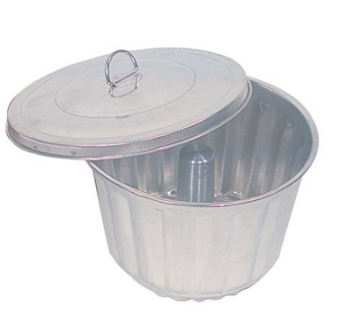

These molds can be purchased online at Amazon.com. You might also be able to find them at Williams Sonoma. It is nice to have two large ones and two small ones. I find it easiest to make double batches of the Christmas Pudding so I have a “spare”, as they keep very well. I have also purchased two much smaller molds that are perfect to make puddings to give as gifts. Hopefully folks enjoy eating them and don’t use them as paperweights!

Just a note regarding English “pudding”. Pudding is a generic term in England that means “dessert”. I believe the word “dessert” is a bit to “French” to suit the British. You will often see on English menus the terms “Starters, Main Course, and Pudding”. It is a bit confounding as an American to hear Apple Pie referred to as “pudding”. Oh well. What can I say? “Two nations, separated by a common language!!”

PINEAPPLE-DATE STEAMED CHRISTMAS PUDDING
VIOLA HENRY

HISTORY: This is a traditional English recipe, basically the “figgy pudding” sung about in the Christmas Carol. The recipe was given to Jacquie Henry by her mother-in-law, Viola Henry. You must have a pudding mold and a trivet for the bottom of a large saucepan in order to make this. It is delicious with whipped cream, lemon sauce or hard sauce. It keeps in the fridge for a week or two, and is also good even after having been frozen. It is good cold – but best warmed. Jacquie has often made these for Christmas gifts for friends.

INGREDIENTS:
Wet mixture:
1 beaten egg
½ cup sugar
½ tsp salt
3 tbs. melted butter
1 cup pineapple juice
1 cup chopped dates (I get them pre-chopped from Wegman’s bulk dept.)
¼ cup chopped raisins (I don’t bother to chop them)
½ cup chopped nuts
1 tsp vanilla
Dry mixture
1 ½ cups flour
¾ tsp baking soda
1 tsp baking powder
1 tsp cinnamon
¼ tsp nutmeg

DIRECTIONS:
- Beat egg, sugar, salt, butter,vanilla, and pineapple juice.
- Stir in fruits and nuts
- Mix together flour, baking soda, baking powder, cinnamon & nutmeg & add to wet ingredients
- Fill greased pudding mold, leaving 1 ½ inches for pudding to expand
- Place trivet in bottom of large saucepan
- Fill saucepan with boiling water about ½ way up the pudding mold
- Steam on low heat for two hours.
- Remove from pan
- Remove cover of pudding mold & Turn upside down on a serving plate to unmold.
- Serve warm with whipped cream, warm lemon or hard sauce.

LEMON SAUCE
JACQUIE HENRY

HISTORY:

We used to use French’s Lemon Pie filling – but that is no longer available. Most pudding mixes have yellow dye in them, which causes breathing problems for the many asthmatics in the family, so Jacquie Henry found an easy recipe for homemade lemon sauce.

INGREDIENTS:

½ cup granulated sugar
1 tbs cornstarch
¼ tsp salt
1 cup boiling water
Juice of one lemon
1tablespoon finely grated lemon peel
1 tbs butter

DIRECTIONS:

- In a saucepan, combine sugar, cornstarch and salt.
- Add boiling water
- Cook, stirring constantly, until mixture is thick and clear.
- Stir in lemon peel, lemon juice, and butter.
- Serve warm over dessert.

HARD SAUCE
JACQUIE HENRY

HISTORY:

Traditional hard sauce contains rum or other liquors. Because of medical problems in the Henry family (primarily asthma), no liquor is in this recipe

INGREDIENTS:

1 cup powdered sugar (10x – very fine for icing)
4 tbsp. butter
1/8 tsp salt
1 tsp vanilla extract
¼ cup heavy cream

DIRECTIONS:

- Sift powdered sugar and set aside
- Beat bitter until soft
- Gradually beat in the sugar until well blended
- Beat in salt and vanilla
- Beat in heavy cream
- When sauce is very smooth, chill thoroughly and serve.

